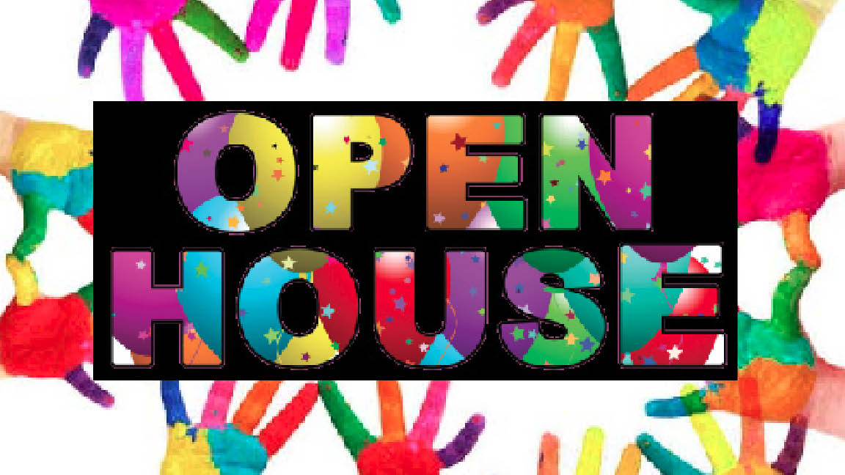

Join us at the Jennie Mose Family Resource Center, 14 South Street Addison NY on Thursday October

5th from 6 to 7:30 PM.

There will be light refreshments along with family fun, activities and information on what the Jennie Mose Family Resource Center has to offer. All services are free to everyone and all families are welcome

Free Glitter Tattoos from the Tattoo Gal

Make your own Pumpkin Rock

Dancing Corn Experiment

Pumpkin Tic Tac Toe

Free Book Giveaway

Make your own silly pumpkin face